23rd May 2013

**Rally Success for Aigner & YOKOHAMA**

*Second win in a row for Aigner*

Andreas Aigner, the Austrian driver currently competing in the FIA ERC, European Rally Championship, concluded his second Rally start of the season in the Production Car cup with another win, this time in Corsica. The partnership between the Austrian and Subaru with the Impreza R4 STI, together with the Austrian based Stohl Racing team and the Japanese tyre manufacturer YOKOHAMA have already brought excellent results early in the season with the potential to make 2013 into an unforgettable and fruitful rally year.

In Corsica, Aigner showed that resilience and skill must be carefully balanced with good technical know-how and indeed the all important decisions on the choice of compound for tyres. His team managed to do just that and came away with an important win in the Production class distancing himself and co-driver Juergen Heigl from the rest of the pack. His performance also earned him an impressive overall 7th place at the ever popular Giru di Corsica. His next rally participation will be at the end of June with the Geko Ypres Rally.

Aigner who was already World Champion in the 2008 PWRC production cup is hopeful and confident that the experience he has accumulated over the past few years in different rallies together with the great team spirit and excellent understanding that exists with Subaru, Stohl racing and the YOKOHAMA team will enable a true challenge in the class championship.

More information on the ERC Rally is available on <http://www.fiaerc.com>

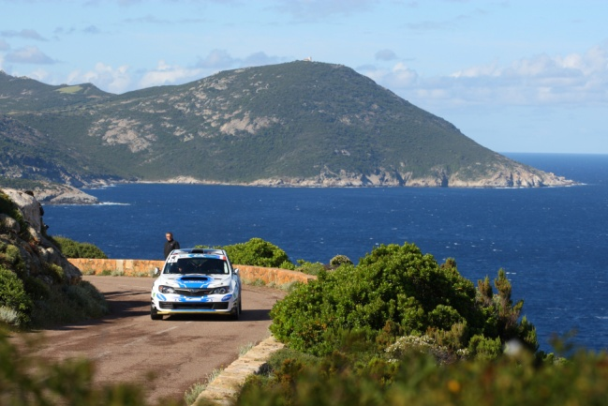

Andreas Aigner